**🧠 SAP SYSTEM & ABAP BASICS – Your Gateway to Enterprise Logic**

**🚀 Introduction: Why ABAP Still Matters**

In the age of web development and cloud computing, you might wonder — *why learn ABAP?*  
Here’s a fact: **over 70% of global business transactions touch an SAP system**, and **ABAP** is the language that powers them.

SAP ABAP (Advanced Business Application Programming) is a high-level programming language created by SAP in the 1980s. It’s the core language used for building applications in the SAP ecosystem, particularly within the **SAP ERP**, **SAP S/4HANA**, and **SAP NetWeaver** platforms.

If you’re working on SAP implementations, migrations, or support, **ABAP isn’t just useful — it’s essential.**

**🔧 1. Data Dictionary (DDIC): The Heart of ABAP**

The **Data Dictionary (SE11)** is where all your database structures live. It defines tables, views, indexes, data types, Tables & more.

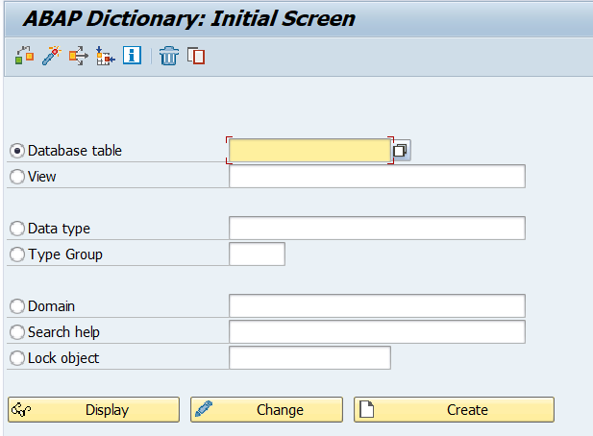

**Key Components:**

* **Tables:** Store actual data (Transparent, Pooled, Clustered)
* **Domains & Data Elements:** Control structure and data type behaviour
* **Views:** Logical joins on multiple tables
* **Search Helps:** Like dropdowns for input fields

💡*Fact:* ABAP tables don’t use primary keys the same way as typical SQL databases. Instead, **the "key field" logic is enforced through the dictionary**, making validations easier to maintain.

**📊 2. ALV Reports: Beyond Boring Lists**

ALV stands for **ABAP List Viewer** — SAP’s way of making reports beautiful, interactive, and useful.  
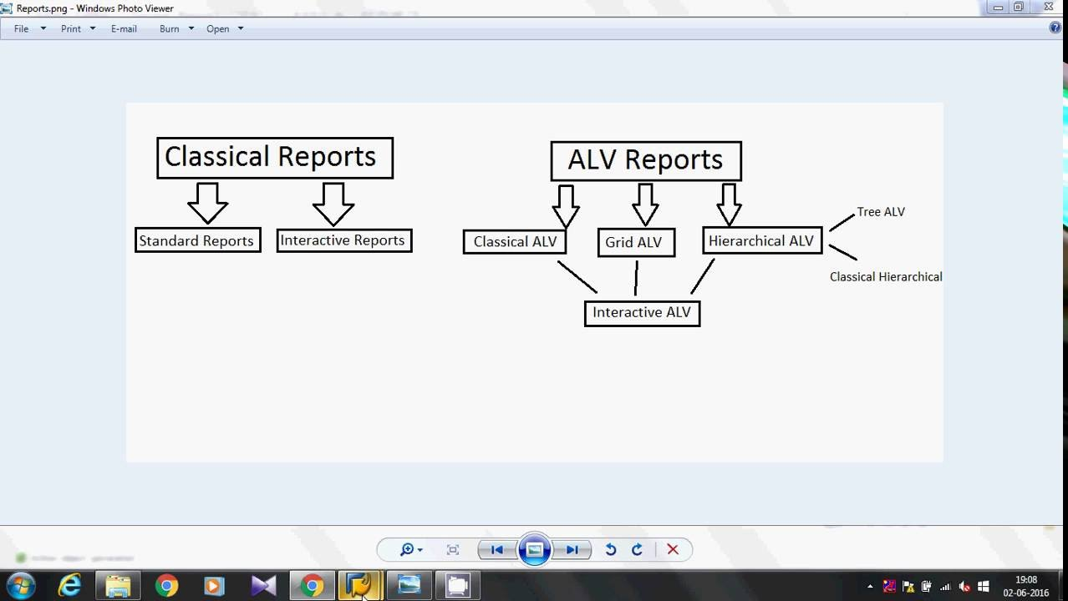

**Types of ALV:**

* **Simple ALV** – Straightforward list
* **Interactive ALV** – Clickable items
* **Hierarchical ALV** – Parent-child data (like invoice and items)

ALV automatically provides:

* Sorting
* Filtering
* Export to Excel
* Totals/Subtotals

🧩 Eg:- *Used In:* Vendor payment reports, purchase history summaries, customer aging reports.

💡 *Did You Know?* With just a few lines of code using REUSE_ALV_GRID_DISPLAY, you can turn a dull report into a user-friendly dashboard.

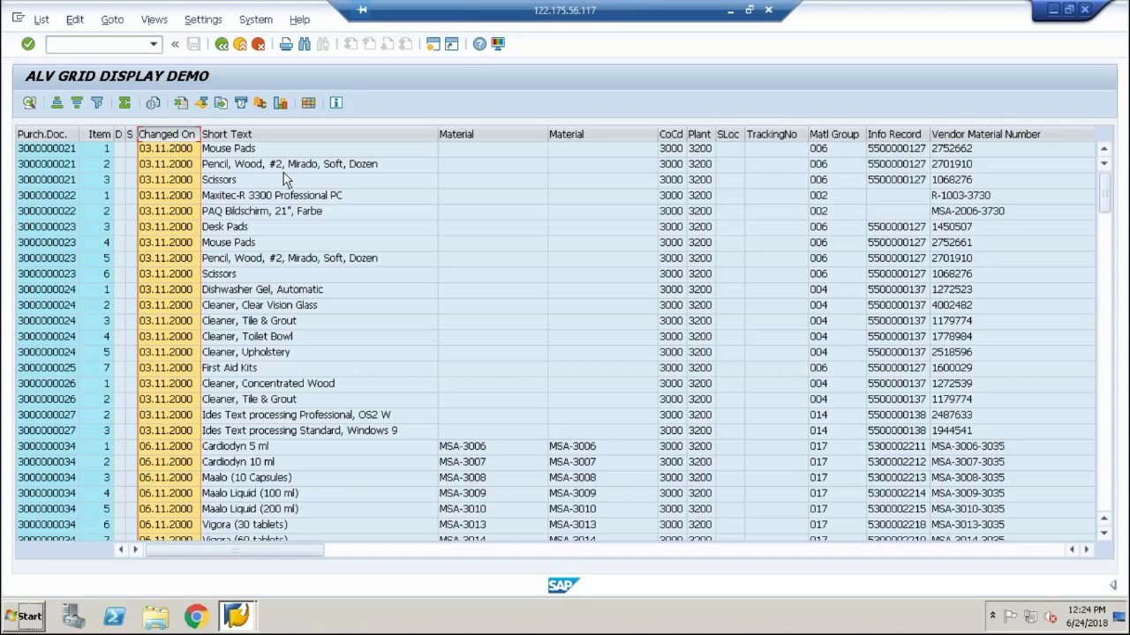

**🔁 3. Function Modules: Reusability is Key**

Function Modules are like helper tools — you can use them across programs.

**Features:-** Created using **SE37**

* Can handle **exceptions** and **return tables**
* Can be **RFC-enabled** for cross-system access  
  for rg:- You have a **Java web application** that needs to fetch employee salary details stored in SAP. **👇 Workflow:**
* You create a **Remote-Enabled Function Module (RFC FM)** in SAP that returns employee salary data.
* SAP exposes this FM as an **RFC endpoint**.
* In your Java app, you use a connector like **SAP JCo (Java Connector)** to call that RFC.
* Data is transferred securely between systems.

📦 **Popular Built-in FMs:**

* **DATE_GET_WEEK** – Get week from date
* **CONVERSION_EXIT_ALPHA_INPUT** – Add leading zeros to customer numbers

💡 *Fact:* Some SAP modules internally call over **10,000+ function modules per day** in large systems.

**📝 4. SAP Scripts & SmartForms: Classic Print Solutions**

Before Adobe came in, **SAP Scripts** and **SmartForms** were the go-to for printed documents.

**SAP Scripts:**

* Layout designed via **SE71**
* Multiple windows (MAIN, LOGO, etc.)
* Outdated but still used in legacy systems

**SmartForms:**

* Easier drag-and-drop UI
* XML-like structure
* Data flow separated from layout logic

🧾 *Used In:* Invoices, Delivery Notes, Pay Slips, Credit Memos

💡 *Fact:* SmartForms can call **nested forms**, letting you reuse subcomponents like footers or terms & conditions!

**📄 5. Adobe Forms: The Modern Era**

**Interactive PDF forms** with dynamic data? That’s where Adobe Lifecycle Designer comes in.

Adobe Forms are:

* Used with Web Dynpro, ECC, and S/4 HANA
* Great for **dynamic and print-ready PDFs**
* Offer **Barcode**, **digital signature**, and **interactive fields**

🧾 *Real Use Case:* Government tax forms or automated purchase order PDFs with input-enabled fields.

💡 *Did You Know?* Adobe Forms can **embed JavaScript** for field validations and calculations!

**🔗 Putting it All Together: A Simple Business Flow**

**Business Requirement:**  
A client wants to print all purchase orders for vendors from the last 3 months, along with item-level details and digital signature.

**ABAP Approach:**

* Read purchase data using **SELECT** with **inner joins** (DDIC)
* Process the logic in a **Function Module**
* Display a preview via **ALV Grid**
* Generate printable **Adobe Form** with item table and vendor signature

💼 This type of end-to-end flow is what makes ABAP so powerful in enterprise applications.

**📚 Conclusion: Mastering ABAP is Your SAP Superpower**

ABAP is more than just syntax — it’s your tool to shape enterprise logic, improve user experiences, and ensure business processes run smoothly.

Whether you're just starting with ALV reports or venturing into Adobe Forms, **mastering the ABAP basics opens doors to SAP's vast career paths**: Developer, Consultant, Solution Architect, or even Tech Lead.

🔎 *Pro Tip:* Explore the transaction codes like SE11, SE37, SE38, SMARTFORMS, and SFP to practice what you just read.

**You need to enter the T-CODES in Command field in SAP to navigate in the SYSTEM.**

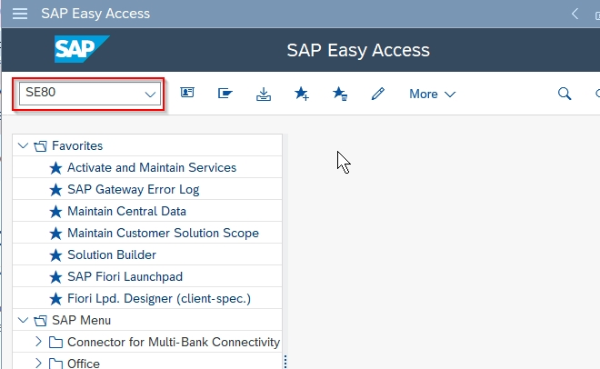

**💡 Bonus: Handy T-Codes to Bookmark**

| **Purpose** | **T-Code** |
| --- | --- |
| Data Dictionary | SE11 |
| Function Modules | SE37 |
| Reports Editor | SE38 |
| SAP Scripts | SE71 |
| Smart Forms | SMARTFORMS |
| Adobe Forms | SFP |
| ALV Reuse FMs | SE93 (to find usage) |
| Object Navigator | SE80 |
| Dump Analysis | ST22 |
| Transport Organizer | SE09/SE10 |
| Transport between clients | SCC1 |
| Display objects in transports | SE95 |
| Transport Management System | STMS (FOR TOC) |